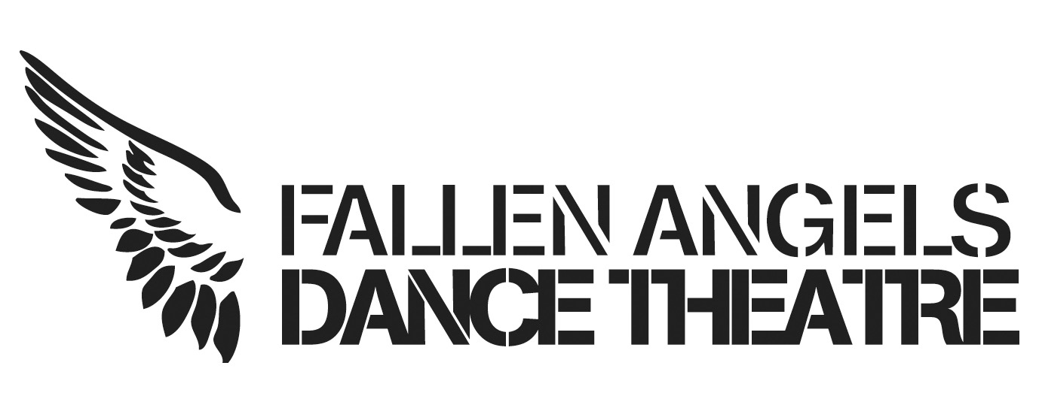
Equal Opportunities Monitoring Form: Access and Inclusion Consultant
Fallen Angels Dance Theatre is committed to promoting equal opportunities, we encourage applications regardless of age, disability, gender, race, religion or belief and sexual orientation and from communities or groups that are under-represented in cultural organisations.

Please complete this form and return it with your application. It will be used for monitoring purposes only and will be separated from your application form prior to shortlisting.
1. Where did you hear about this opportunity?

2. First half of your postcode:

3. Gender (self identified)
- Female
- Male
- Non-binary
- Prefer not to say

Is your gender different to that which is was assumed to be at birth?:
- Yes
- No
- Prefer not to say

Sexual Orientation:
- Bisexual
- Gay Man
- Gay Woman/Lesbian
- Heterosexual/Straight
- Prefer not to say

3. Age:

4. What do you consider your ethnicity to be?
If you would prefer to self-define your ethnic origin, please enter details in the ‘Other' section:
Select your answer

Ethnicity:
- White British
- White Irish
- Gypsy or Irish Traveller
- Any Other White Background
- Mixed White and Black Caribbean
- White and Black African
- White and Asian
- Any other Mixed/Multiple ethnic background
- Indian
- Pakistani
- Bangladeshi
- Chinese
- Any other Asian background
- African
- Caribbean
- Any other Black background
- Arab
- Any other ethnic background
- Prefer not to say

4. Disability Status:
Please tell us whether you identify as Deaf or Disabled, or have a long-term health condition
- Deaf
- Disabled (including mental health)
- Long term health condition(including mental health)
- Non Deaf or Disabled
- Prefer not to say

5. Are you in Recovery from Addiction?
- Yes
- No
- Prefer not to say

www.fallenangelsdt.org
Fallen Angels Dance Theatre North West:
Company limited by Guarantee no: 08909000,
Registered Charity: 1158251
Registered address: 39 Toll Bar Road Chester CH3 5QU

