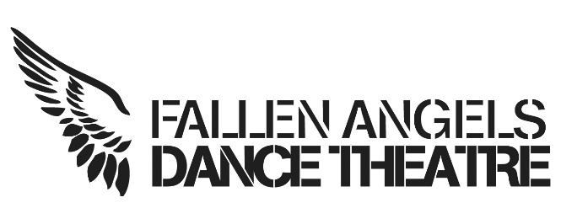
Fallen Angels Dance Theatre (FADT) Board Membership Application Form

Personal Details
First Name: | Family Name:
Organisation: | Role/Job Title:

Address for correspondence, including your postcode (if appointed this address will appear on a public register and will be used as the address to which FADT will send any documentation):
Telephone (Daytime):
Telephone (Evening):
Mobile:
Email:
Fax:

Other Directorships:
Business Occupation:

I declare that the information on this form is correct. I confirm that I have not been disqualified as a Director under company law or as a trustee under charity law and am eligible to serve on the FADT Board. I understand my obligations as a Director and agree to comply with company law.
Signed: Date:

Equal Opportunities Statement
FADT is committed to equality of opportunity in its role as an employer and in its role as a provider of services and facilities. FADT’s aim is to ensure that the services and programmes it provides meet the needs of the communities it serves and are accessible by all.
Help us monitor the diversity and balance of the Board.

0 | 1 | 2 | 3 | 4 | 5
 |  |  |  |  |  | Training
 |  |  |  |  |  | Arts Management
 |  |  |  |  |  | Inclusive Practice
 |  |  |  |  |  | Dance
 |  |  |  |  |  | Film/ Multi Media
 |  |  |  |  |  | Social Policy
 |  |  |  |  |  | Financial Management
 |  |  |  |  |  | Youth Arts
 |  |  |  |  |  | Previous Board Experience
 |  |  |  |  |  | Private Sector

Please indicate what skills you have and at what level from 0 (none) to 5 (excellent).
0 | 1 | 2 | 3 | 4 | 5 |  |  | 0 | 1 | 2 | 3 | 4 | 5
 |  |  |  |  |  | Training |  |  |  |  |  |  |  | Equality and Diversity
 |  |  |  |  |  | Arts Management |  |  |  |  |  |  |  | Fundraising
 |  |  |  |  |  | Inclusive Practice |  |  |  |  |  |  |  | Governance
 |  |  |  |  |  | Dance |  |  |  |  |  |  |  | Health and Safety
 |  |  |  |  |  | Film/MultiMedia |  |  |  |  |  |  |  | Information Technology
 |  |  |  |  |  | Social Policy |  |  |  |  |  |  |  | Legal
 |  |  |  |  |  | Financial Management |  |  |  |  |  |  |  | Marketing and PR
 |  |  |  |  |  | Youth Arts |  |  |  |  |  |  |  | Personnel/employment
 |  |  |  |  |  | Previous Board Experience |  |  |  |  |  |  |  | Quality standards
 |  |  |  |  |  | Private Sector |  |  |  |  |  |  |  | Information, Advice and Guidance
 |  |  |  |  |  | Business Support |  |  |  |  |  |  |  | Strategic planning

Please tell us which type of organisation you work (previous role) in:
- Arts Organisation
- Funder
- Further or Higher Education
- Local Authority
- Business
- Freelance
- Practitioner

Other? (please specify):
Please use this space to tell us about the skills, experience and knowledge you will bring to the Board, to tell us why you are interested in Board membership, and to give us any additional relevant information. Please continue on a separate sheet if necessary

References
Please give the name, address and telephone number of two people who know you and your work (not relatives).
Name: | Name:
Position: | Position:
Address including postcode: | Address including postcode:
Telephone no: | Telephone no:

Additional Reference:

Please return the completed form to:
Fallen Angels Dance Theatre
39 Toll Bar Road
Chester
CH3 5QU
or
e: claire@fallenangelsdt.org

Fallen Angels Dance Theatre North West:
Company limited by Guarantee no: 08909000,
Registered Charity: 1158251
Registered address: 39 Toll Bar Road, Chester, CH3 5QU

